

**NAME: AYESHA HASSAN**

**ROLL NO: FA19-BSE-110**

**SECTION: BSE-7C**

**SUBJECT: DATA WAREHOUSING AND DATA MINING**

**MODERATOR: MAM MAMUNA FATIMA**

**DATE: October 2, 2022**

**LAB TASK 01:**

**QUESTION NO 01:**

**The purpose of this assignment is to understand following SQL queries syntax and the purpose. You have to make a database of your choice in SQL Server or any other DBMS and run the following SQL queries on it. The output of this assignment is a document containing the SQL queries plus the screen shots of the output tables.**

**Additional points will be given to those groups who will make GUI along with as well.**

Select

SELECT `fname` FROM staff

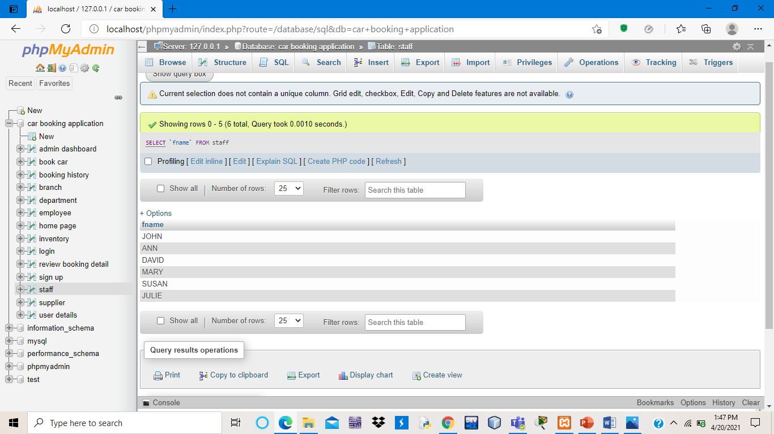

[SELECT](http://localhost/phpmyadmin/url.php?url=https://dev.mysql.com/doc/refman/8.0/en/select.html) `lname`,`branchno` FROM staff WHERE branchno='B005'

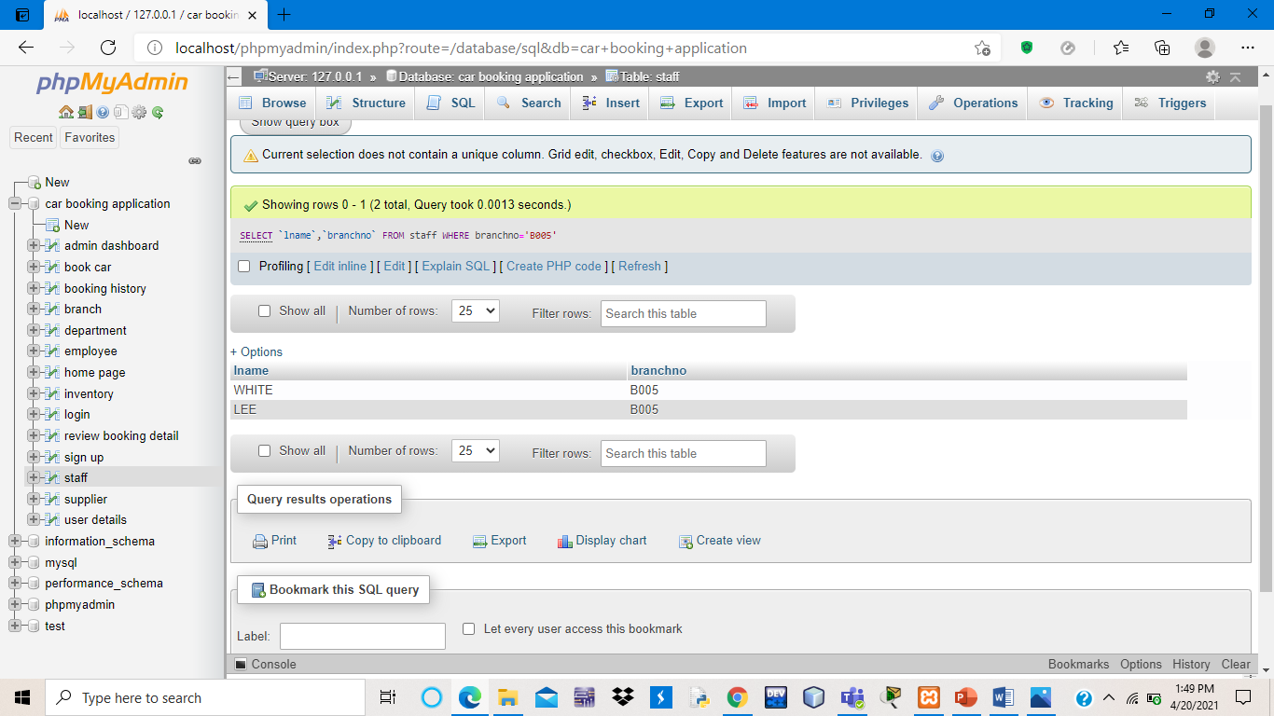

Insert

[INSERT](http://localhost/phpmyadmin/url.php?url=https://dev.mysql.com/doc/refman/8.0/en/insert.html) INTO branch (branch_NO, b_street,b_City,b_Postcode) [VALUES](http://localhost/phpmyadmin/url.php?url=https://dev.mysql.com/doc/refman/8.0/en/miscellaneous-functions.html#function_values) ('B005','22 DEER RD','LONDON','SW1 4EF'), ('B007','16 ARGLL ST','ABERDEEN','AB2 3SUF'), ('B003','163 MAIN STEET','ISLAMABAD','SW1 F'), ('B004','32 MANSI RD','BRISTOL','BS99 4EF'), ('B002','56 CLOVER RD','LONDON','NW10 4EF')

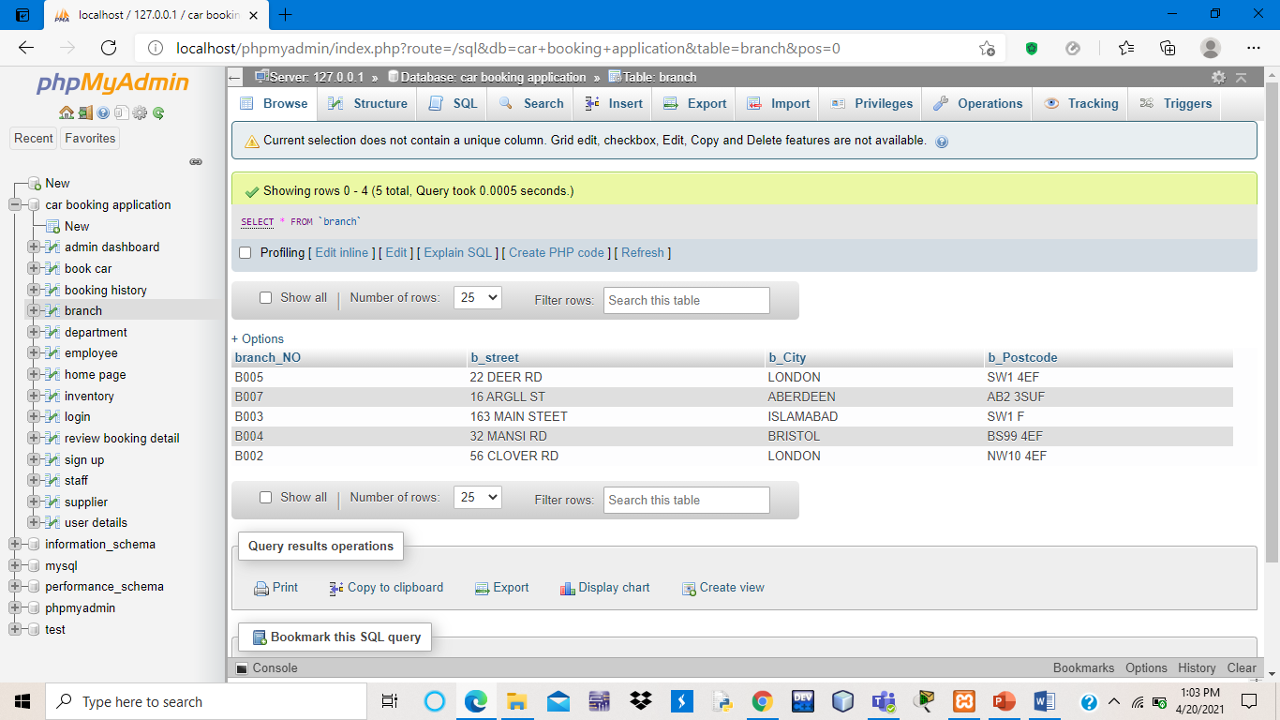

Update

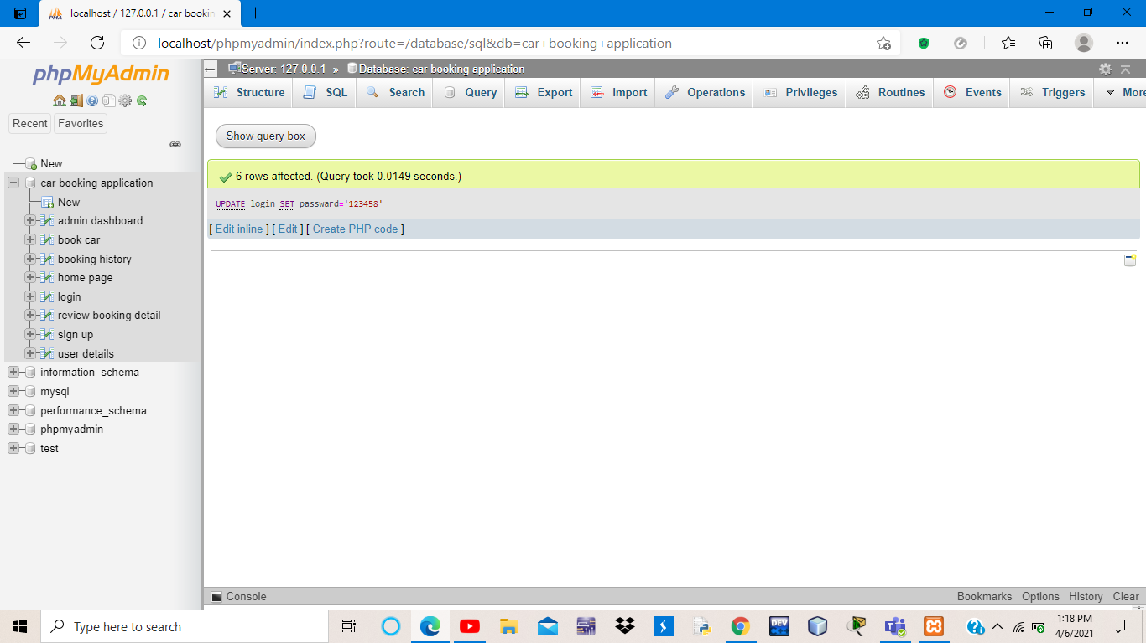

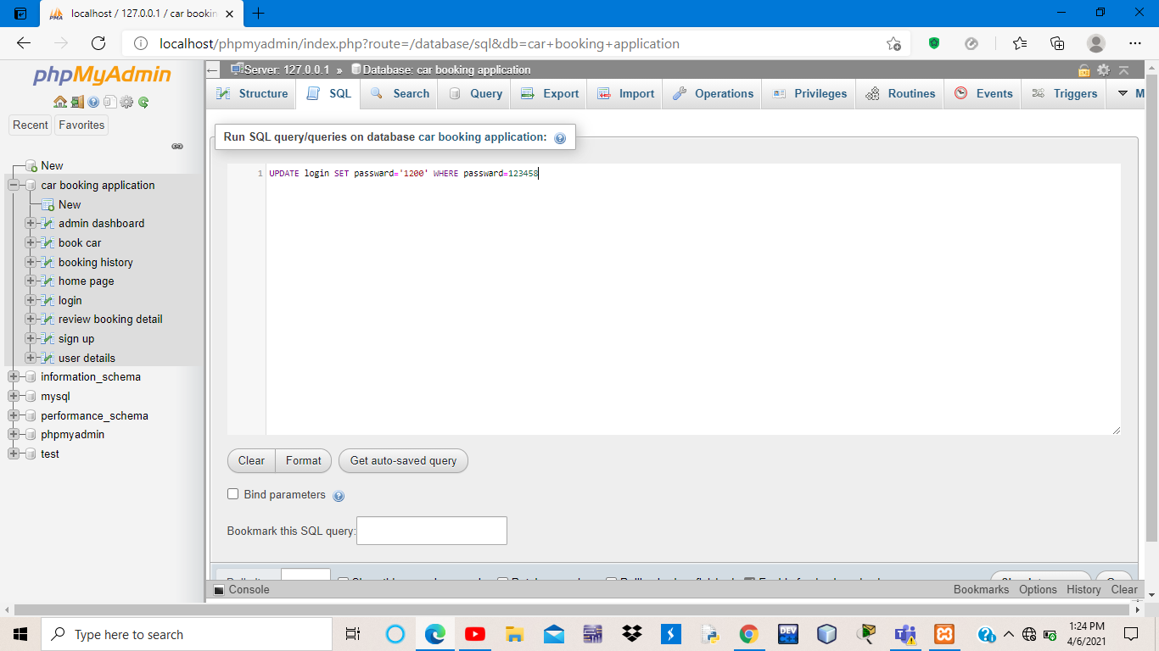

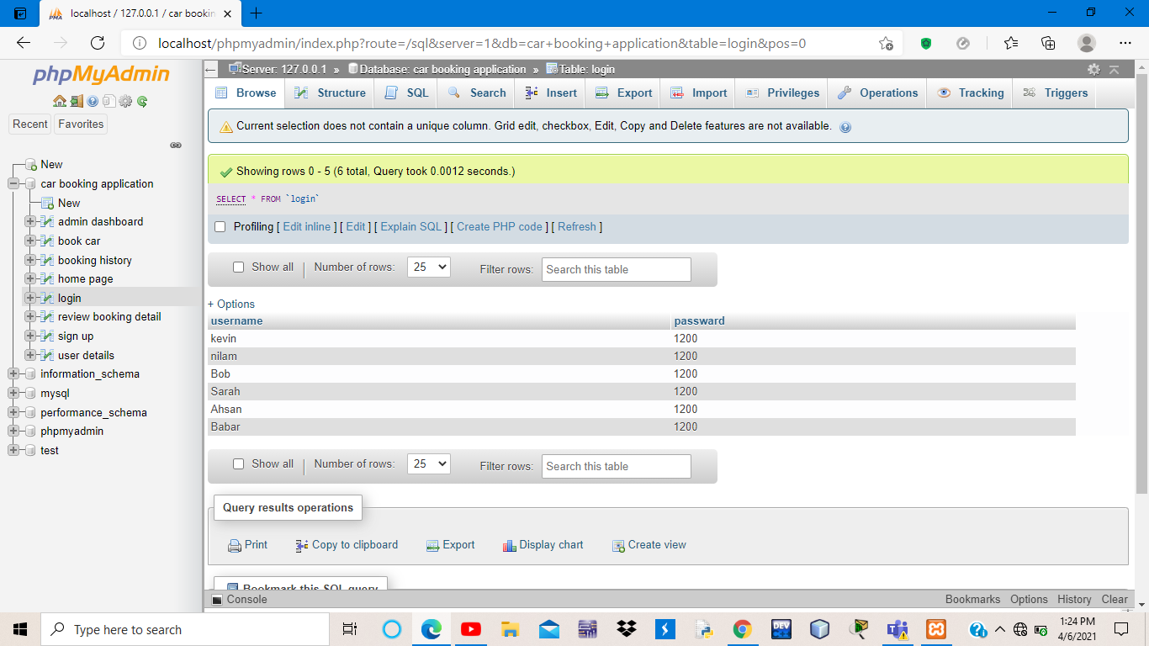

Delete

[ALTER](http://localhost/phpmyadmin/url.php?url=https://dev.mysql.com/doc/refman/8.0/en/alter-table.html) [TABLE](http://localhost/phpmyadmin/url.php?url=https://dev.mysql.com/doc/refman/8.0/en/alter-table.html) admin DROP COLUMN updationDate

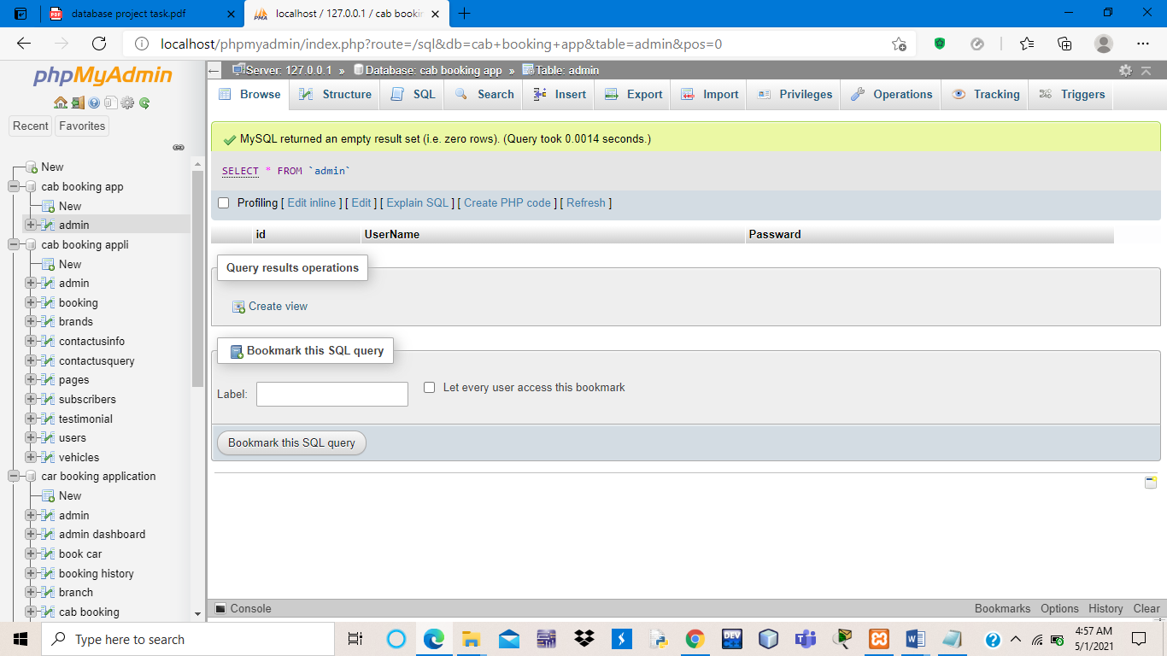

Distinct

[SELECT](http://localhost/phpmyadmin/url.php?url=https://dev.mysql.com/doc/refman/8.0/en/select.html) [COUNT](http://localhost/phpmyadmin/url.php?url=https://dev.mysql.com/doc/refman/8.0/en/group-by-functions.html#function_count)(DISTINCT `id`) FROM booking

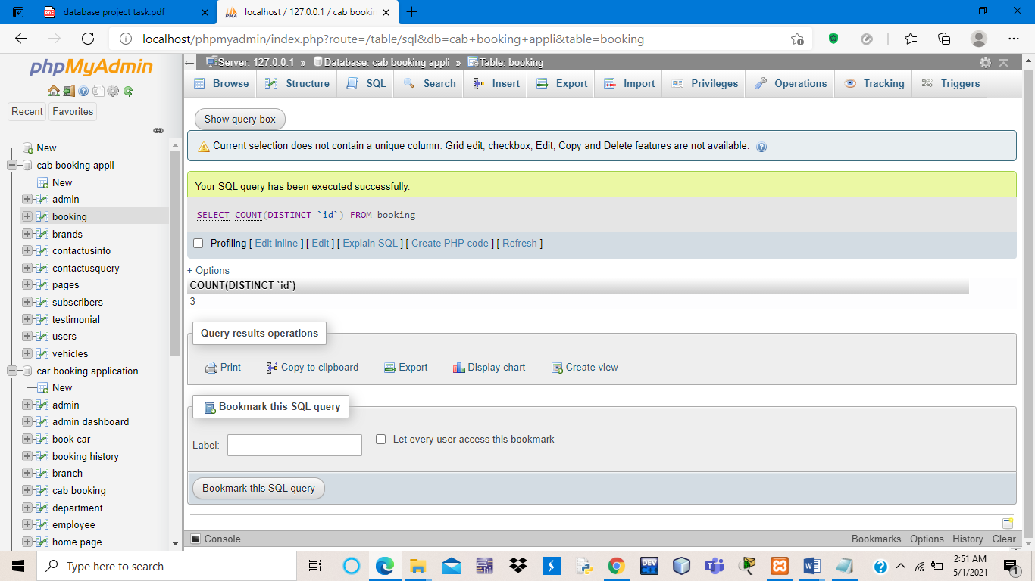

[SELECT](http://localhost/phpmyadmin/url.php?url=https://dev.mysql.com/doc/refman/8.0/en/select.html) 'id', [COUNT](http://localhost/phpmyadmin/url.php?url=https://dev.mysql.com/doc/refman/8.0/en/group-by-functions.html#function_count)('id') AS myCount FROM booking GROUP BY 'id' ORDER by 'id'

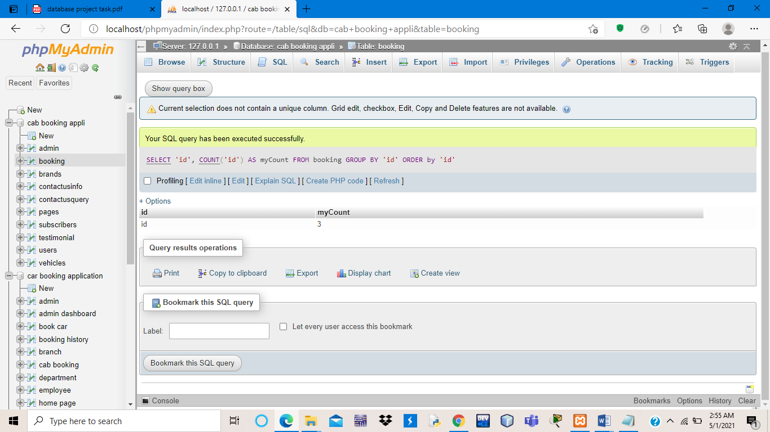

Where clause

[SELECT](http://localhost/phpmyadmin/url.php?url=https://dev.mysql.com/doc/refman/8.0/en/select.html) `id`,`BrandName`FROM brands WHERE `BrandName`='Maruti'

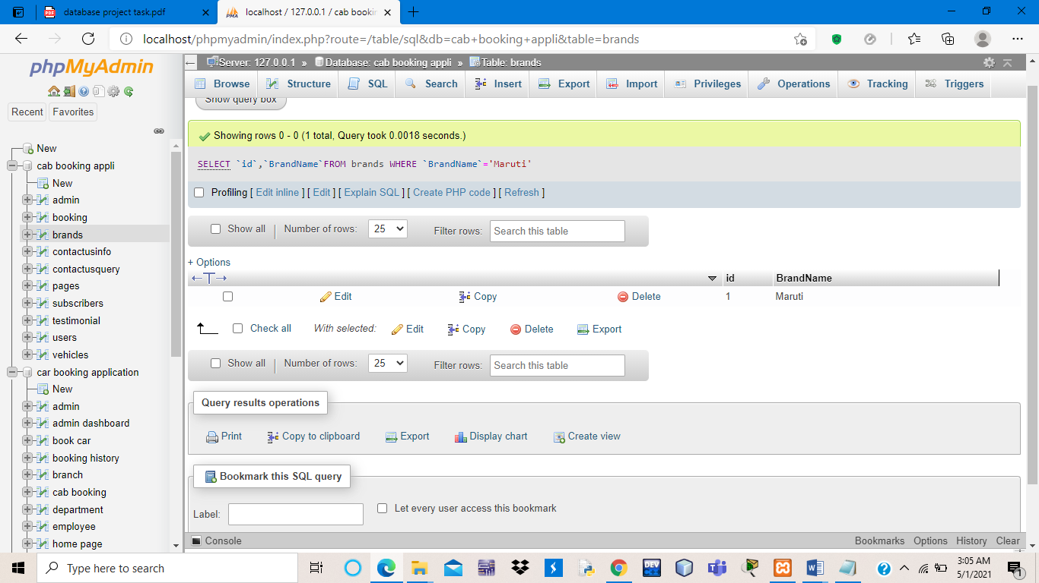

AND/OR

IN

[SELECT](http://localhost/phpmyadmin/url.php?url=https://dev.mysql.com/doc/refman/8.0/en/select.html) `id`, `BrandName` FROM `brands` WHERE `BrandName` [IN](http://localhost/phpmyadmin/url.php?url=https://dev.mysql.com/doc/refman/8.0/en/comparison-operators.html#function_in)('Maruti')

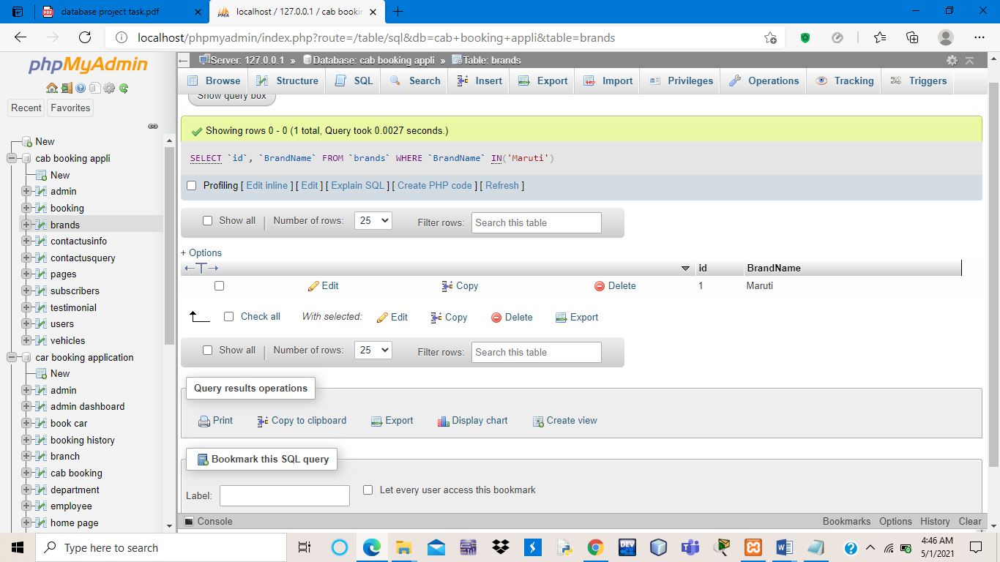

ALIAS

BETWEEN

**BETWEEN**

[SELECT](http://localhost/phpmyadmin/url.php?url=https://dev.mysql.com/doc/refman/8.0/en/select.html) * FROM `booking` WHERE `id` BETWEEN 2 [AND](http://localhost/phpmyadmin/url.php?url=https://dev.mysql.com/doc/refman/8.0/en/logical-operators.html#operator_and) 4

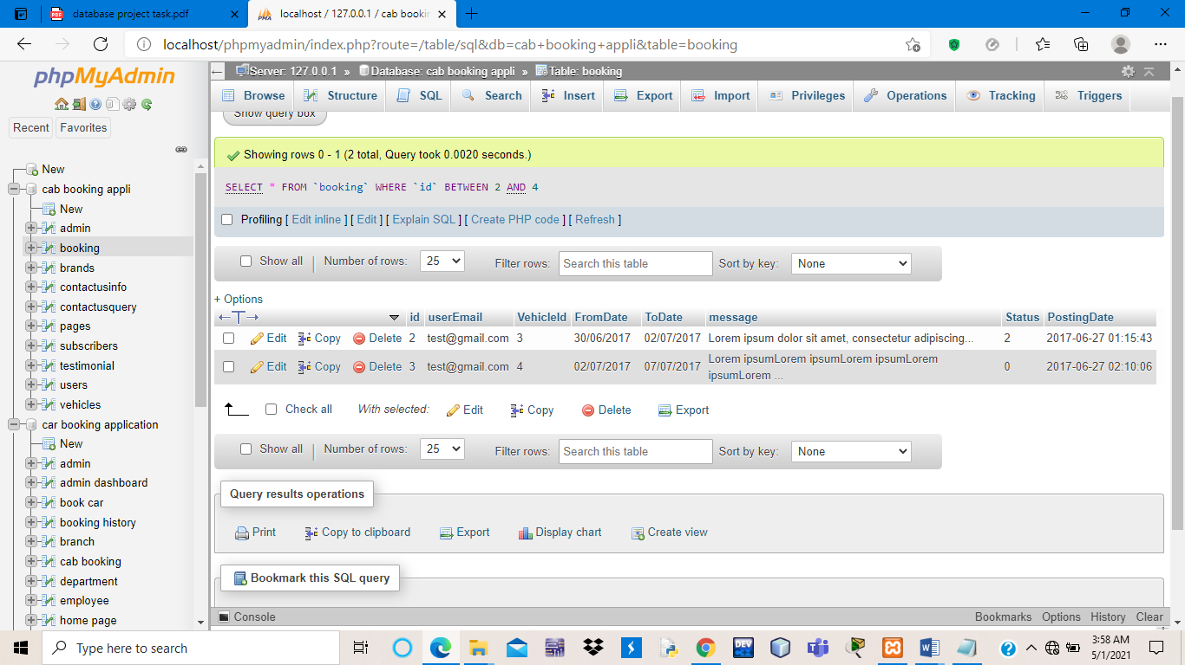

LIKE

[SELECT](http://localhost/phpmyadmin/url.php?url=https://dev.mysql.com/doc/refman/8.0/en/select.html) `id`, `BrandName` FROM `brands` WHERE `BrandName` [like](http://localhost/phpmyadmin/url.php?url=https://dev.mysql.com/doc/refman/8.0/en/string-comparison-functions.html#operator_like) 'M%'

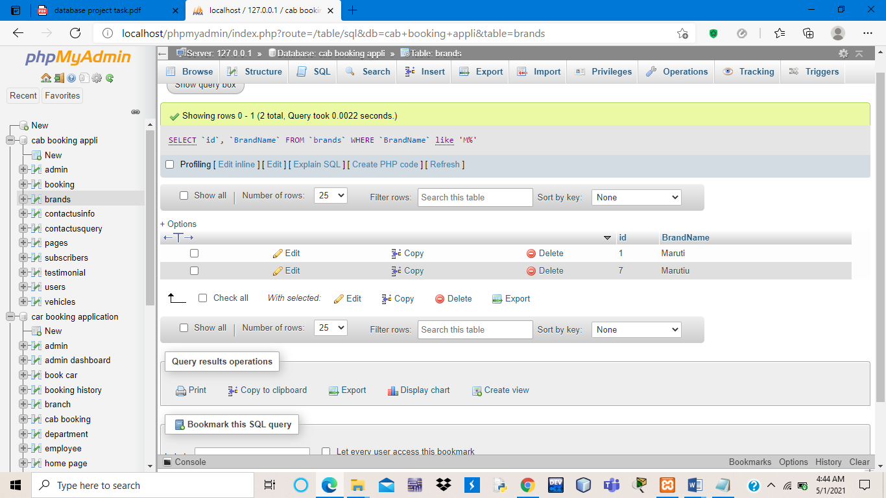

COUNT

[SELECT](http://localhost/phpmyadmin/url.php?url=https://dev.mysql.com/doc/refman/8.0/en/select.html) [COUNT](http://localhost/phpmyadmin/url.php?url=https://dev.mysql.com/doc/refman/8.0/en/group-by-functions.html#function_count)(*) FROM staff

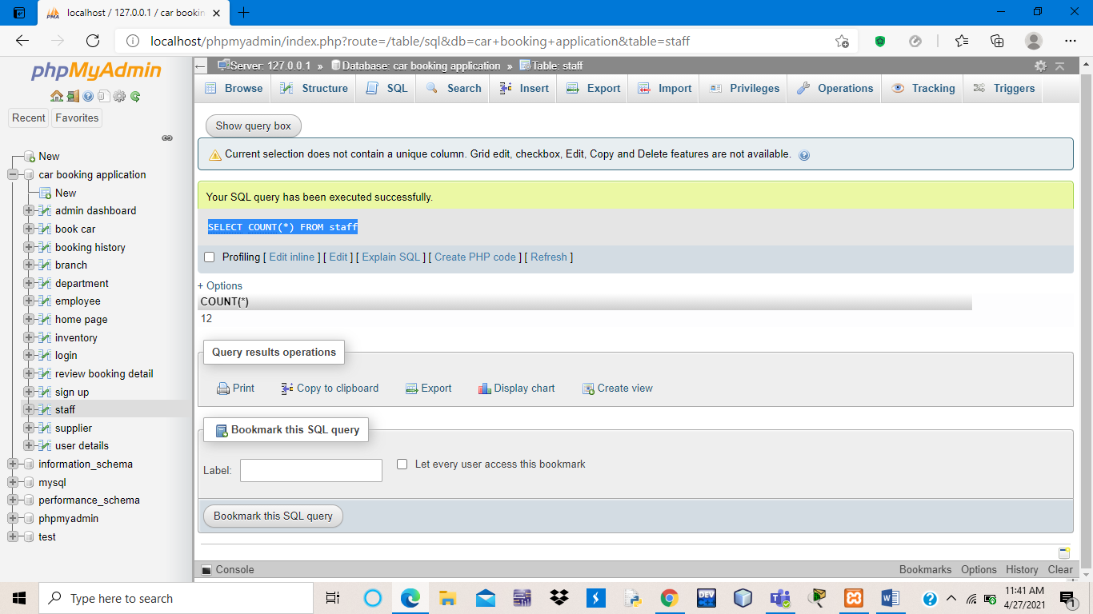

[SELECT](http://localhost/phpmyadmin/url.php?url=https://dev.mysql.com/doc/refman/8.0/en/select.html) [COUNT](http://localhost/phpmyadmin/url.php?url=https://dev.mysql.com/doc/refman/8.0/en/group-by-functions.html#function_count)(branchno) FROM staff

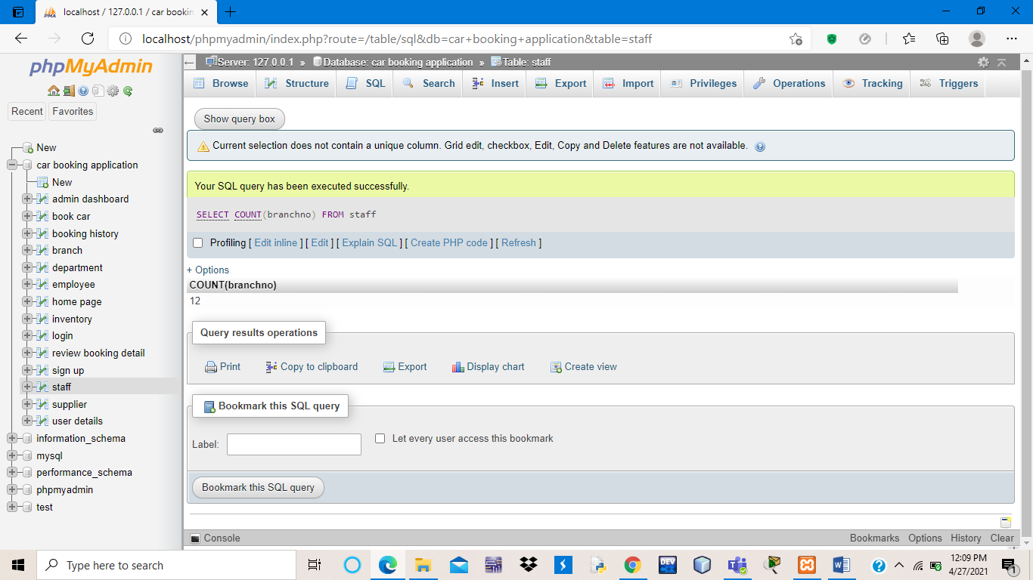

[SELECT](http://localhost/phpmyadmin/url.php?url=https://dev.mysql.com/doc/refman/8.0/en/select.html) [COUNT](http://localhost/phpmyadmin/url.php?url=https://dev.mysql.com/doc/refman/8.0/en/group-by-functions.html#function_count)(DISTINCT s_Salary) FROM staff

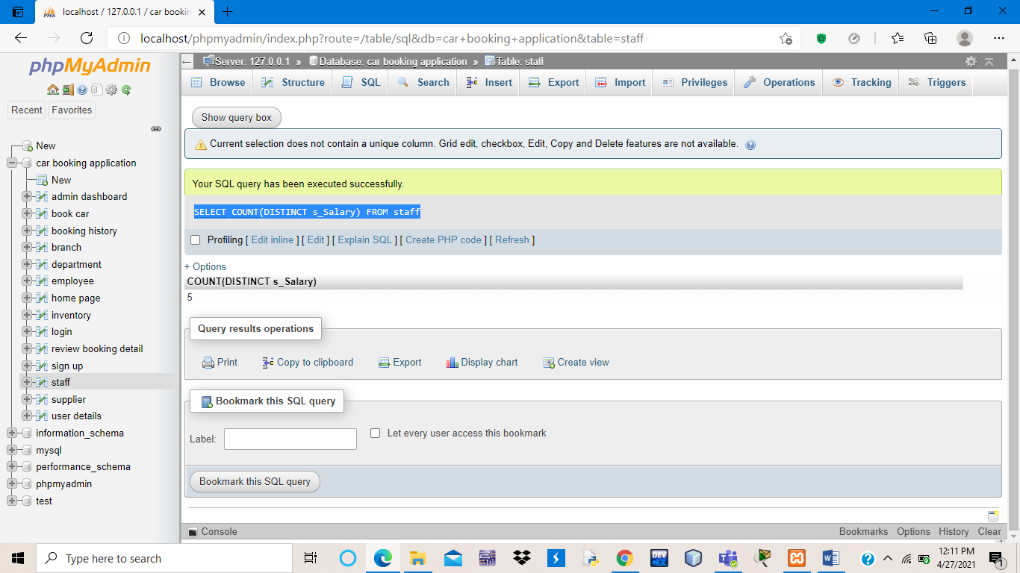

[SELECT](http://localhost/phpmyadmin/url.php?url=https://dev.mysql.com/doc/refman/8.0/en/select.html) [COUNT](http://localhost/phpmyadmin/url.php?url=https://dev.mysql.com/doc/refman/8.0/en/group-by-functions.html#function_count)(fname) AS fnameDAVID FROM staff WHERE fname='DAVID

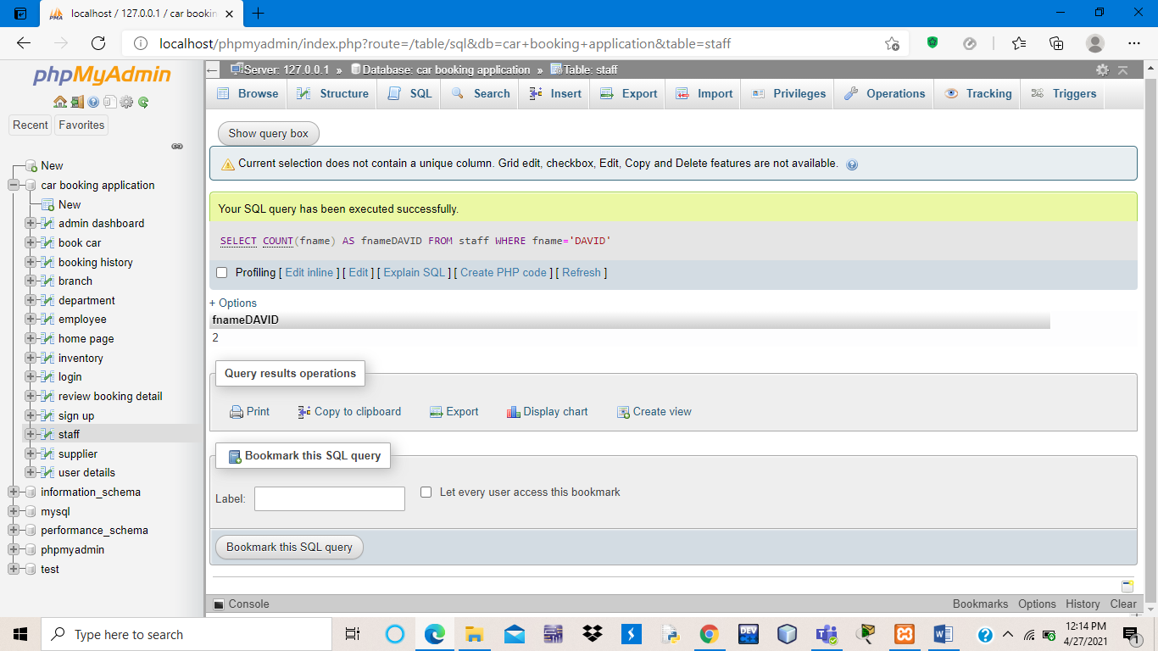

ORDER BY

GROUP BY

HAVING

INNER JOIN

[SELECT](http://localhost/phpmyadmin/url.php?url=https://dev.mysql.com/doc/refman/8.0/en/select.html) * from admin INNER JOIN book_cab where admin.id = book_cab.id

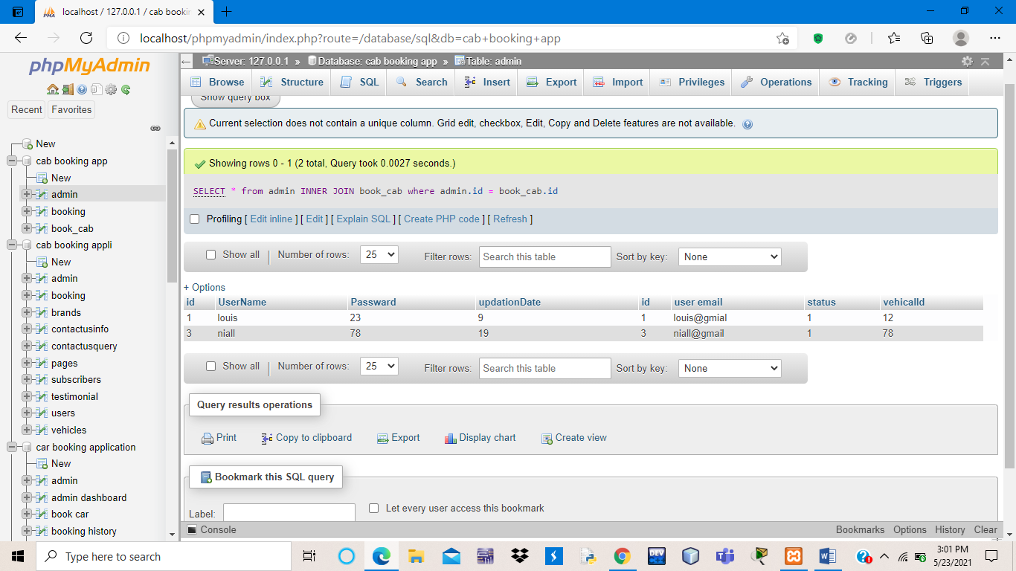

FULL JOIN

SELF JOIN

**4-Left Outer Join:**

[SELECT](http://localhost/phpmyadmin/url.php?url=https://dev.mysql.com/doc/refman/8.0/en/select.html) * FROM admin [LEFT](http://localhost/phpmyadmin/url.php?url=https://dev.mysql.com/doc/refman/8.0/en/string-functions.html#function_left) OUTER JOIN book_cab ON (admin.id = book_cab.id)

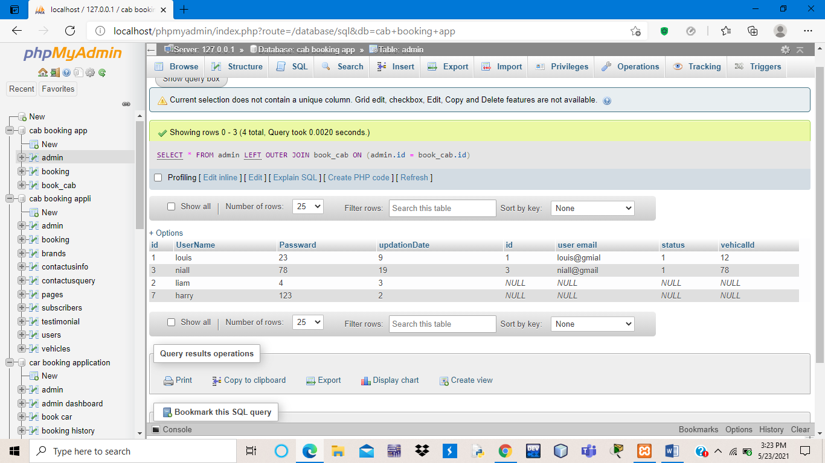

Right Outer Join:

[SELECT](http://localhost/phpmyadmin/url.php?url=https://dev.mysql.com/doc/refman/8.0/en/select.html) * FROM admin [RIGHT](http://localhost/phpmyadmin/url.php?url=https://dev.mysql.com/doc/refman/8.0/en/string-functions.html#function_right) OUTER JOIN book_cab ON (admin.id = book_cab.id)

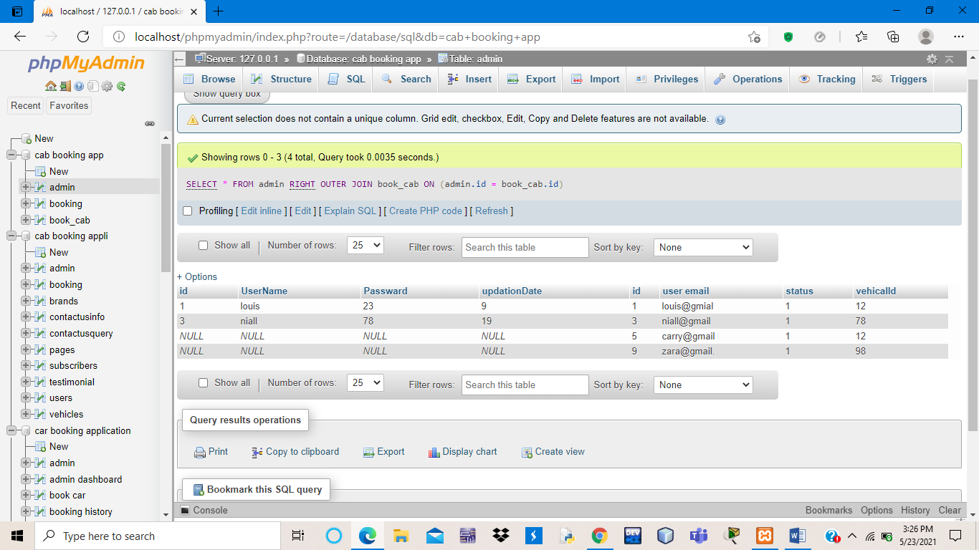

CREATE VIEW

MAX,MIN

[SELECT](http://localhost/phpmyadmin/url.php?url=https://dev.mysql.com/doc/refman/8.0/en/select.html) [MAX](http://localhost/phpmyadmin/url.php?url=https://dev.mysql.com/doc/refman/8.0/en/group-by-functions.html#function_max)(passward) FROM login

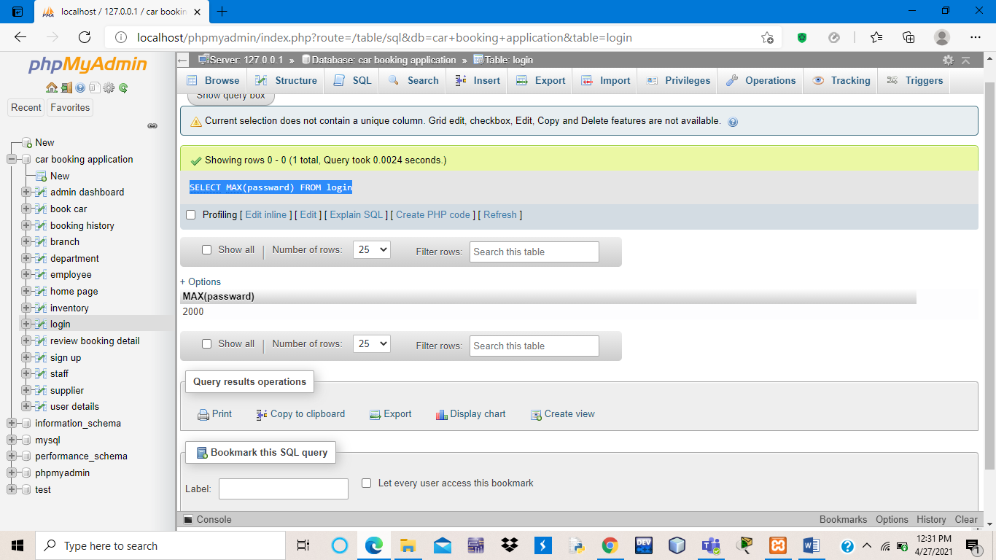

[SELECT](http://localhost/phpmyadmin/url.php?url=https://dev.mysql.com/doc/refman/8.0/en/select.html) [MAX](http://localhost/phpmyadmin/url.php?url=https://dev.mysql.com/doc/refman/8.0/en/group-by-functions.html#function_max)(passward) AS Largestpassward FROM Login

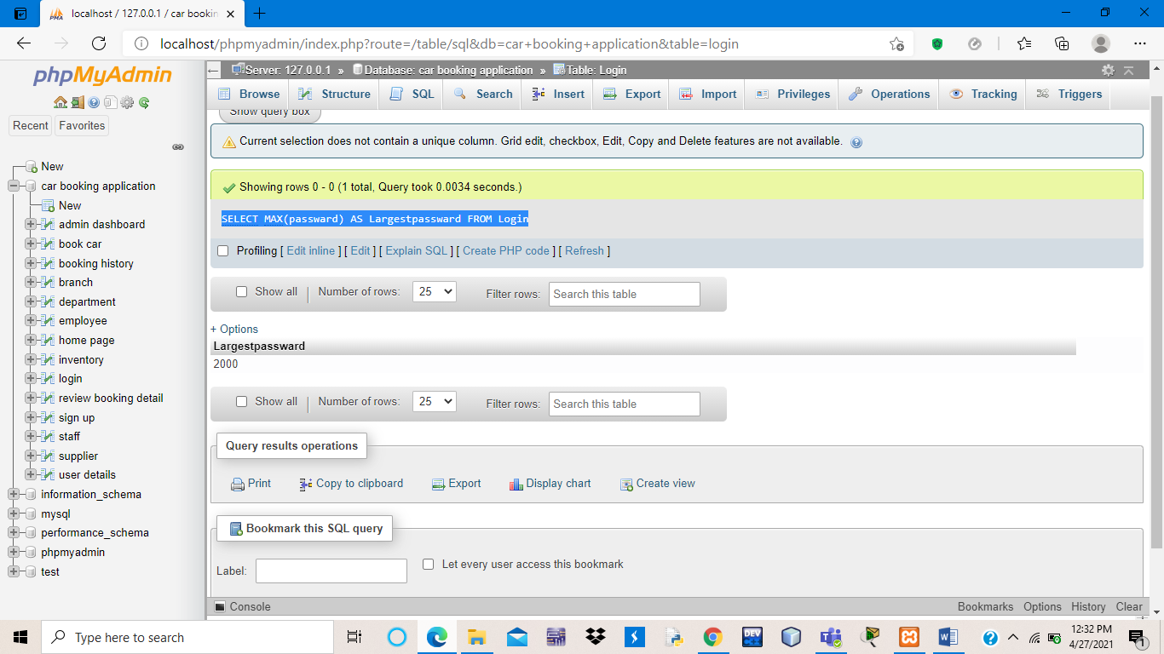

6-SQL MIN() Function

[SELECT](http://localhost/phpmyadmin/url.php?url=https://dev.mysql.com/doc/refman/8.0/en/select.html) [MIN](http://localhost/phpmyadmin/url.php?url=https://dev.mysql.com/doc/refman/8.0/en/group-by-functions.html#function_min)(passward) FROM login

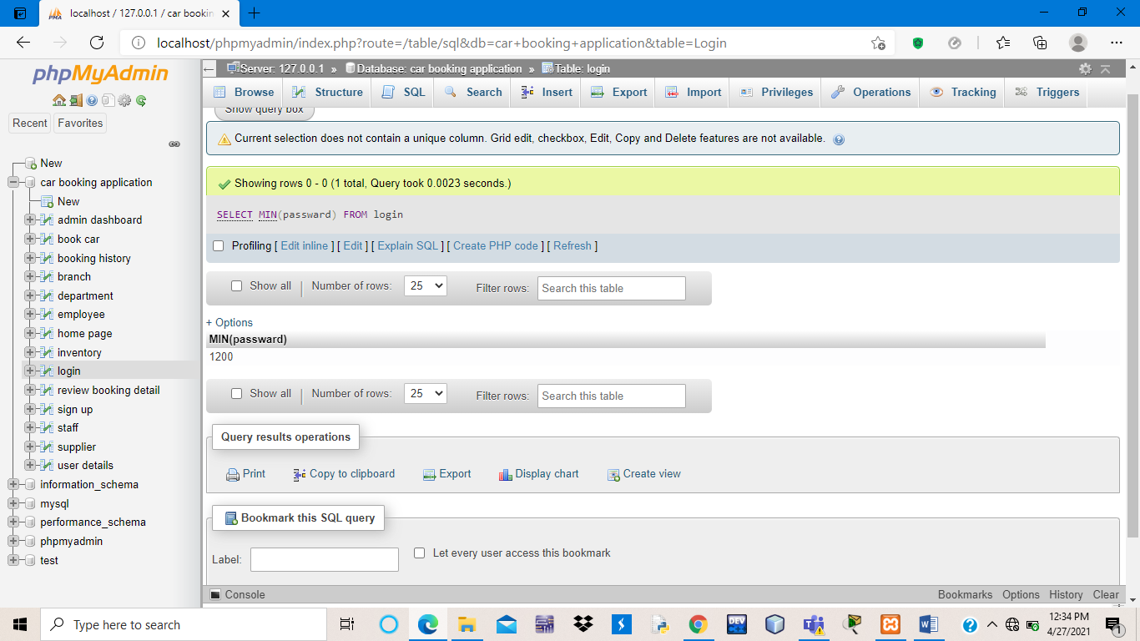

[SELECT](http://localhost/phpmyadmin/url.php?url=https://dev.mysql.com/doc/refman/8.0/en/select.html) [MIN](http://localhost/phpmyadmin/url.php?url=https://dev.mysql.com/doc/refman/8.0/en/group-by-functions.html#function_min)(passward) AS Smallestpassward FROM Login

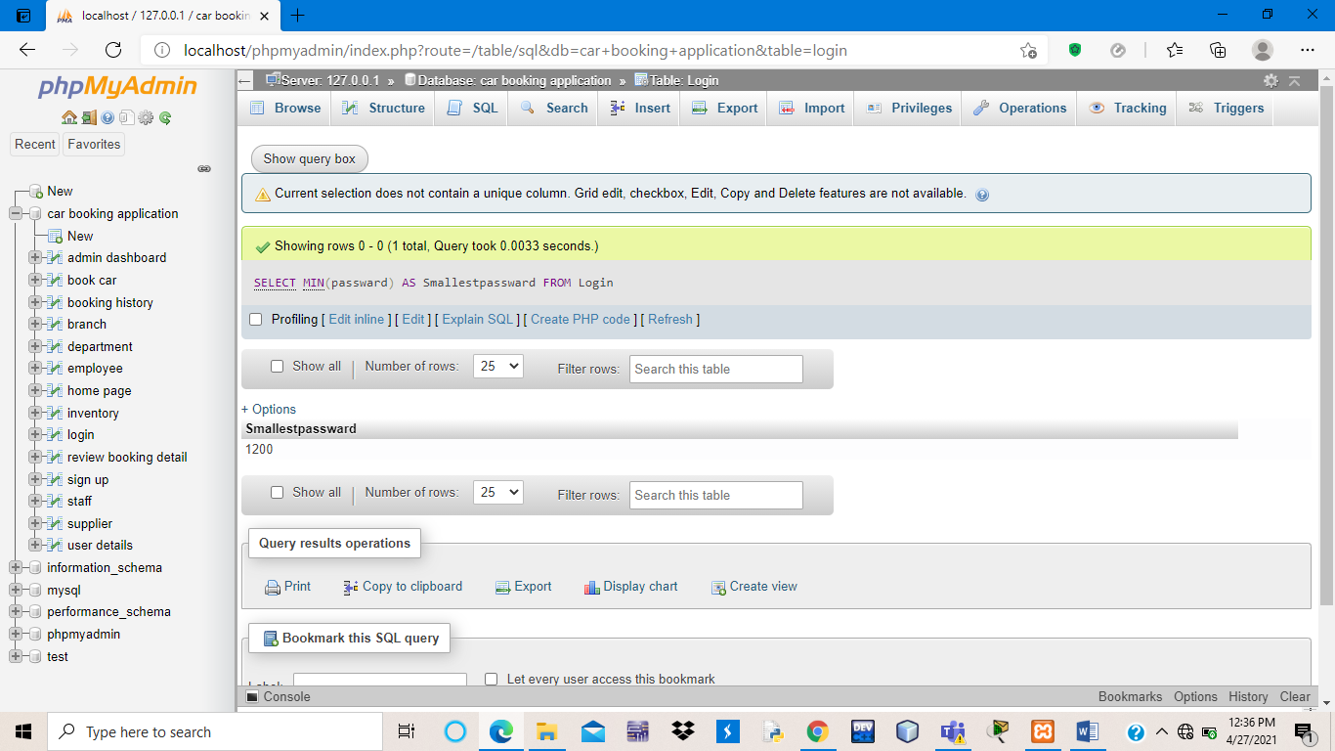

**2-AVG function**

[SELECT](http://localhost/phpmyadmin/url.php?url=https://dev.mysql.com/doc/refman/8.0/en/select.html) [AVG](http://localhost/phpmyadmin/url.php?url=https://dev.mysql.com/doc/refman/8.0/en/group-by-functions.html#function_avg)(passward) FROM login

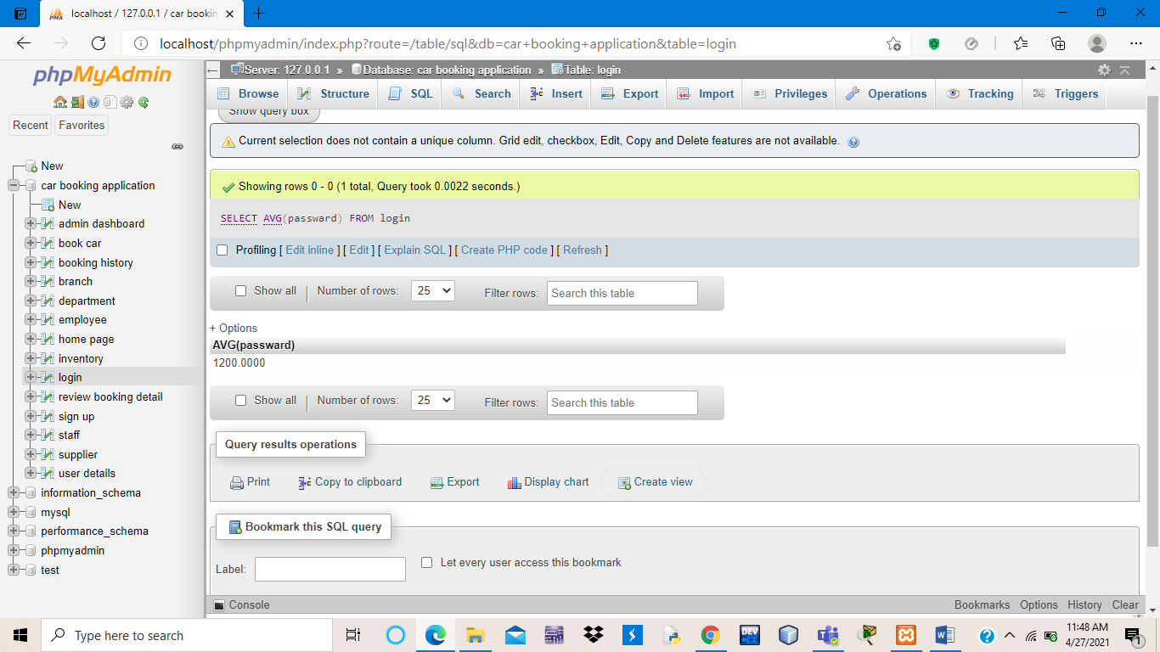

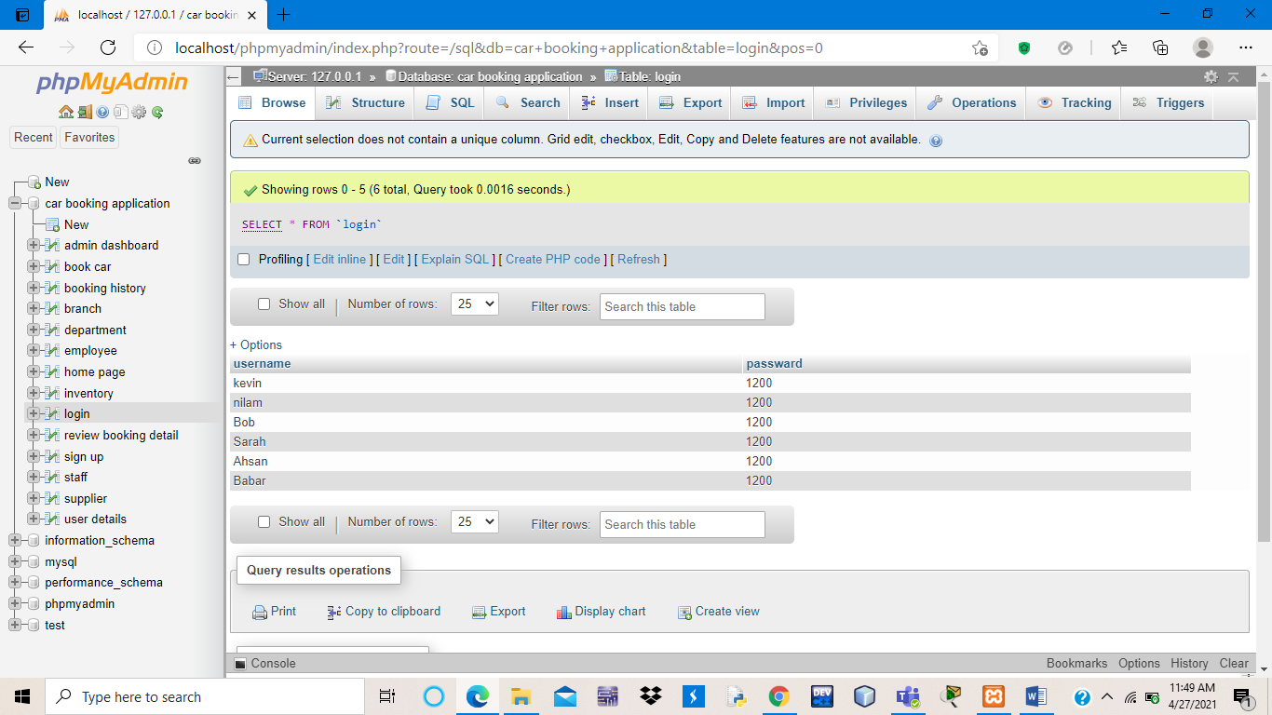

SQL STRING FUNCTIONS

SQL UNION